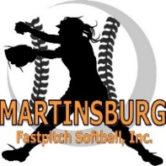

Martinsburg Fastpitch Softball Sponsorship
On behalf of Martinsburg Fastpitch Softball, Inc., we would like to thank you for your sponsorship of our 2026 softball season. Thanks to your generosity we can help players develop their skills, build character through adversity and foster a love of their softball.
We offer the following sponsorship packages that are available:
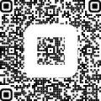
- Supporter Package $150 includes:
  - Facebook and Website recognition
  - Public thank you during opening ceremonies
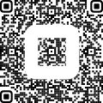
- Sponsor Package $250 includes:
  - 4x4 banner on field,
  - Facebook and Website recognition with company logo,
  - Public thank you during opening ceremonies.
- Team Sponsor Package $500 includes:
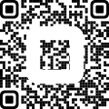
  - One 4x4 banner on the field & one 2x2 banner on your team’s dugout,
  - Featured social media posts on Facebook,
  - Website recognition with company logo,
  - Public thank you during opening ceremonies.
Please mark the sponsorship package above.
For Team Sponsor Package:
Team Name:
Sponsor Name:
Please print, this is how it will show on all advertisements (banners, social media).
All sponsor logos can be emailed to MBFPSecretary@gmail.com
Contact Name:
Contact Email:

This section to be completed by Martinsburg Fastpitch Board of Directors:
Date payment received:
Payment Method: Cash _____ Check # Payable to: Martinsburg Fastpitch Softball
Date banner(s) ordered:
Date banner(s) hung:

